

**BLG 477E**

**MULTIMEDIA COMPUTING**

CRN: 22539

INSTRUCTOR: HAZIM KEMAL EKENEL

**ASSIGNMENT #3**

**Counting Birds & Color Classification**

Submission Date: 10.05.2015

STUDENT NAME: TUĞRUL YATAĞAN

STUDENT NUMBER: 040100117

# Introduction

In this project Counting Birds and Color Classification are done.

* In counting birds; segmentation algorithm and connected component analysis method are used for count birds in an image.
* In color classification; red, orange, yellow, green, blue, white and violet colors are classified in an image

# Development and Operating Environment

MATLAB R2012b has been used on Ubuntu 14.04 operation system. Example screenshot:

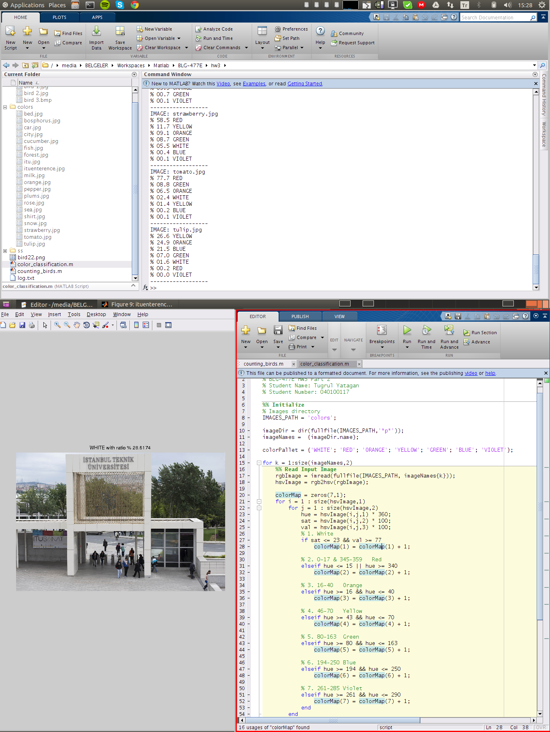

# 1. Counting Birds

Segmentation algorithm and connected component analysis method are used for count bird number in an image.

Counting algorithm phases are:

1. Convert to grayscale
2. Calculate Otsu’s method segmentation threshold
3. Threshold segmentation with calculated threshold
4. Smooth segmented image with Gaussian filter with 6x6, σ = 6 Gaussian kernel
5. Morphologically close image with disk shape morphological structuring element
6. Calculate 4-connectivity connected components

Otsu’s method is chosen for calculate segmentation threshold. Also smoothing is essential for removing noise in segmented image.

Disk shape with radius 1 is chosen for morphologically close image, disk is a simple shape for structuring element. With morphological closing, bird shapes become clearer to distinguish by connected components method.

“**counting_birds.m”** runs in MATLAB without parameter. Example run:

>> counting_birds

Original and segmented bird images are shown below with counted bird numbers on their caption. When “**counting_birds.m”** runs, it shows all the segmented images in “**bird images/**” directory with counted bird numbers on their caption.

**9** bird counted in “bird 1.jpg”

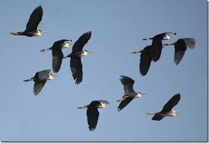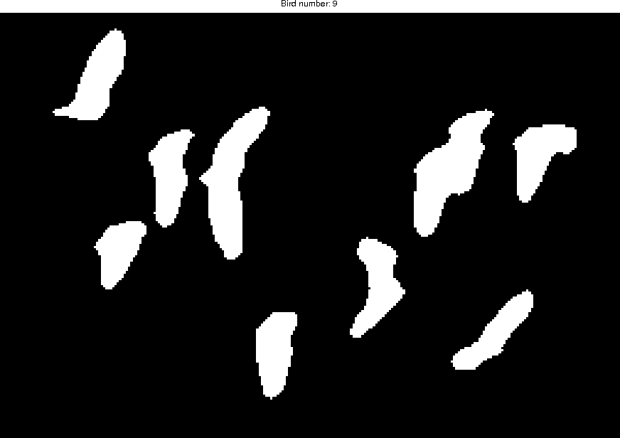

9 bird are counted in bird “bird 1.jpg”. Two birds on the upper left corner are overlapped. So they cannot be distinguished. As a result of this 9 bird are counted in image incorrectly instead of 10.

Originally **6** bird counted in “bird 2.jpg”

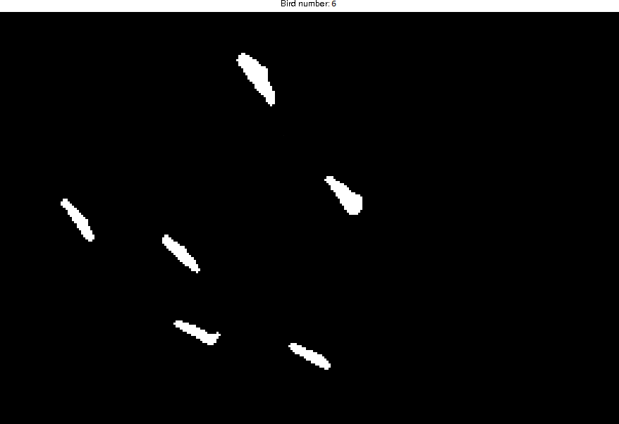

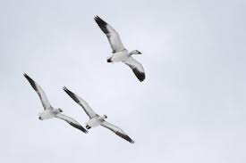

Originally 6 bird are counted in bird “bird 2.jpg”. Threshold value for segmentation is not sufficient for segments bird’s wings and their body from background, so only their wings are segmented from background. As a result of this 6 bird are counted in image incorrectly instead of 3.

**2** bird counted in “bird 2.jpg” by threshold augmentation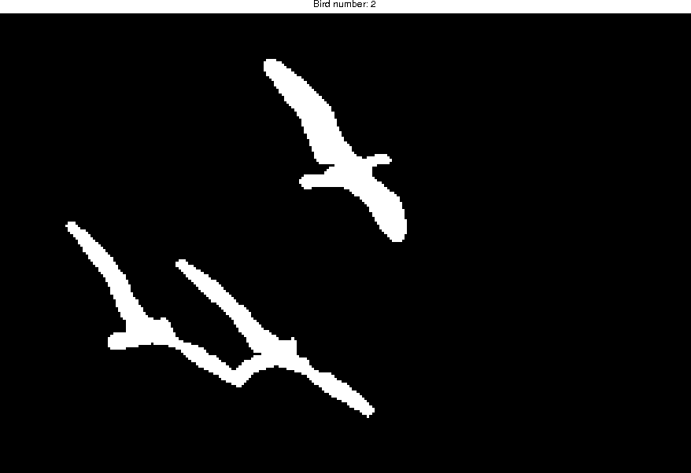

Threshold level for segmentation is increased by 20% to distinguish background but 2 birds incorrectly counted in ‘’bird 2.jpg’. Two birds in lower right corner are overlapped, as a result of this 2 birds are counted as one bird so total 2 birds are counted in image incorrectly instead of 3.

**22** bird counted in “bird 3.bmp”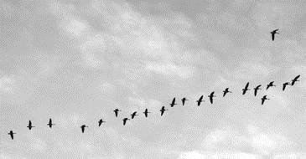

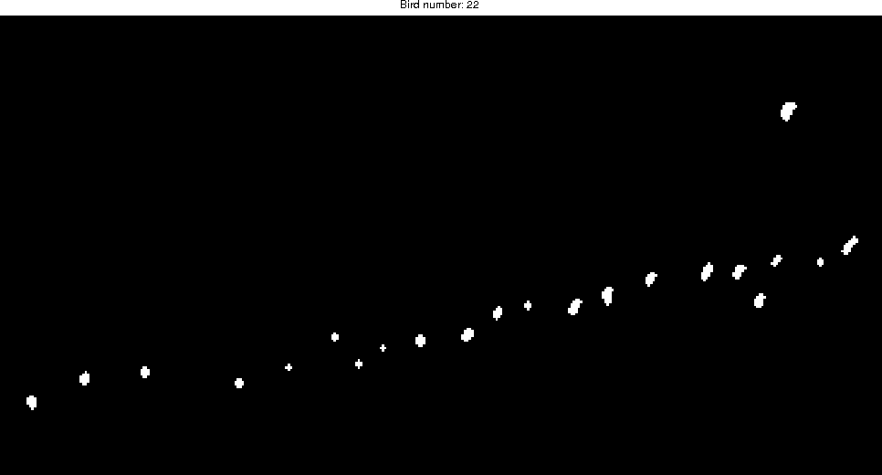

22 bird are correctly counted in bird “bird 3.bmp”.

# 2. Color Classification

Firstly all images converted RGB color model to HSV color model to get hue values. Hue values of HSV gives color information. Hue value range is 0 to 2π in MATLAB hue range is 0 to 1 proportional to 2π for digital representation. All colors has its own subrange in 2π hue range except white. Whiteness is extracted from saturation and value values of HSV. Saturation and value is ranged from 0 to 100 in MATLAB saturation and value values range are 0 to 1 proportional to 100. Small saturation and high value values of HSV represent white color. Red, orange, yellow, green, blue, white and violet colors can be extracted from HSV color model with these rules. Hue value is enough for extract red, orange, yellow, green, blue and violet colors. Saturation and value values of HSV is sufficient for extract white color.

As a result of classification extraction method, colors are classified according to this chart:

* White: 0-23 Sat & 77-100 Value range
* Red: 0-15 & 340-359 Hue range
* Orange: 16-40 Hue range
* Yellow: 46-70 Hue range
* Green: 80-163 Hue range
* Blue: 194-250 Hue range
* Violet: 261-285 Hue range

“**color_classification.m”** runs in MATLAB without parameter. Example run:

>> color_classification

Example images are shown below with dominant color in the image and other color percentages. When “**color_classification.m”** runs, it shows all the images in “**color/**” directory with a dominant color name image caption and it prints color percentages to the console.

**“color_classification.m”** gives 20/20 correct color classification results for provided images.

**Violet** 26.7%

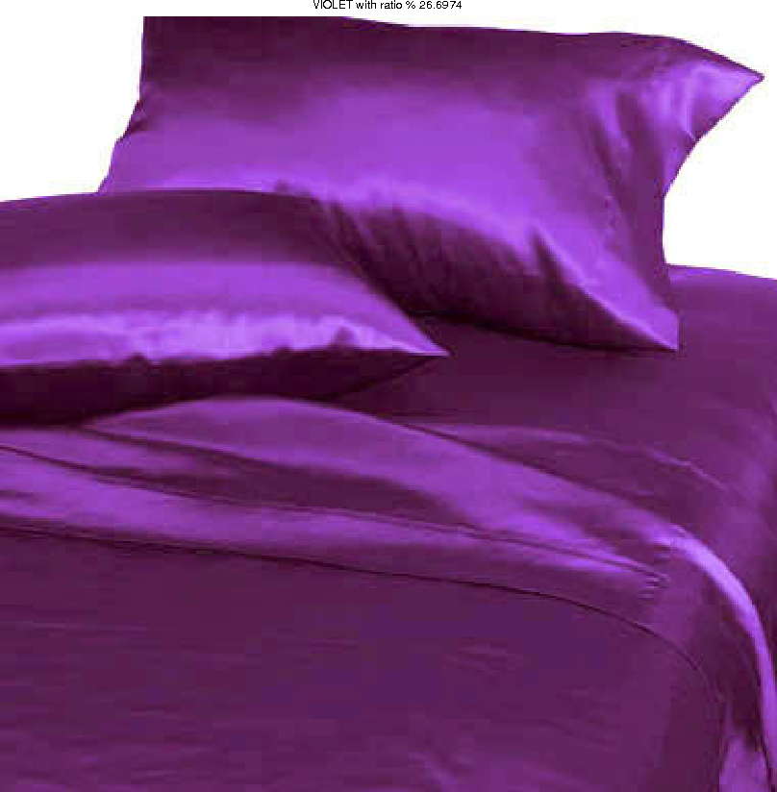

IMAGE: bed.jpg

% 26.7 VIOLET

% 07.9 WHITE

% 00.1 RED

% 00.0 ORANGE

% 00.0 YELLOW

% 00.0 GREEN

% 00.0 BLUE

**Blue** 96.9%

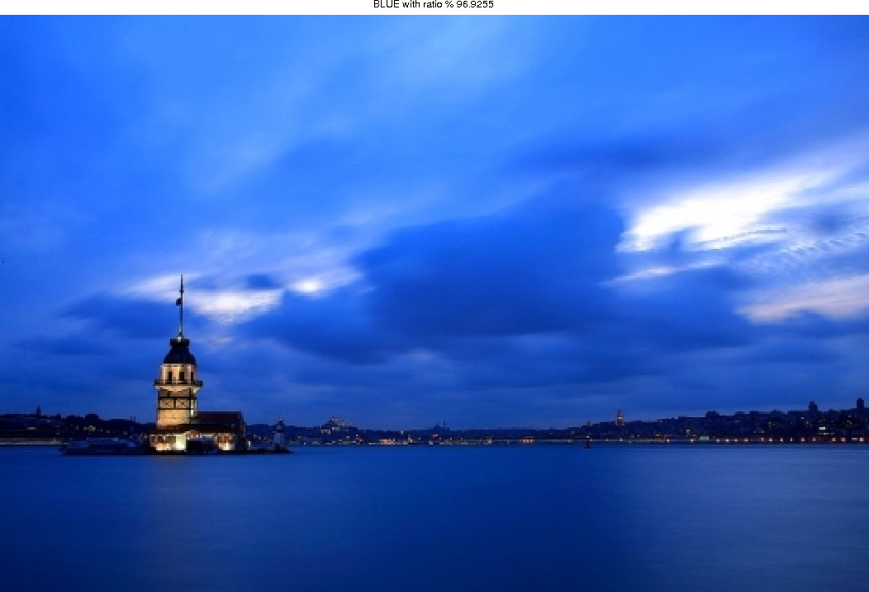

IMAGE: bosphorus.jpg

% 96.9 BLUE

% 02.0 WHITE

% 00.5 ORANGE

% 00.2 VIOLET

% 00.1 RED

% 00.0 YELLOW

% 00.0 GREEN

**Red** 78.8%

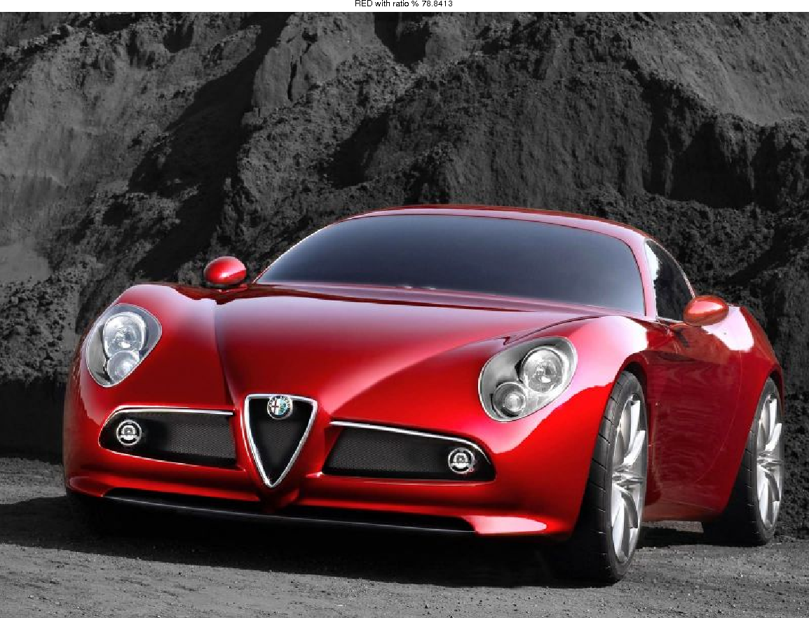

IMAGE: car.jpg

% 78.8 RED

% 07.7 BLUE

% 03.4 WHITE

% 01.1 GREEN

% 01.0 VIOLET

% 00.7 ORANGE

% 00.6 YELLOW

**Violet** 45.6%

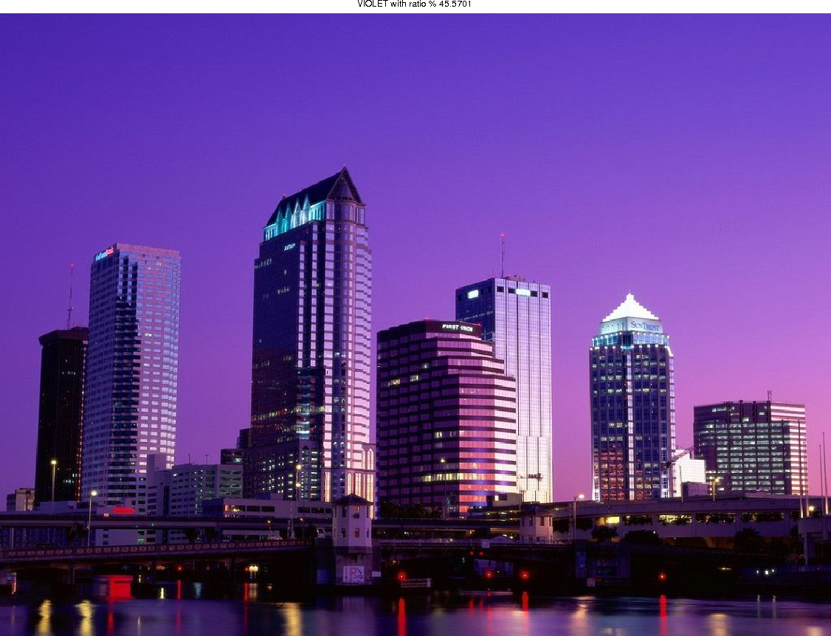

IMAGE: city.jpg

% 45.6 VIOLET

% 05.4 RED

% 04.4 BLUE

% 02.5 WHITE

% 01.5 ORANGE

% 00.2 YELLOW

% 00.0 GREEN

**Green** 95.7%

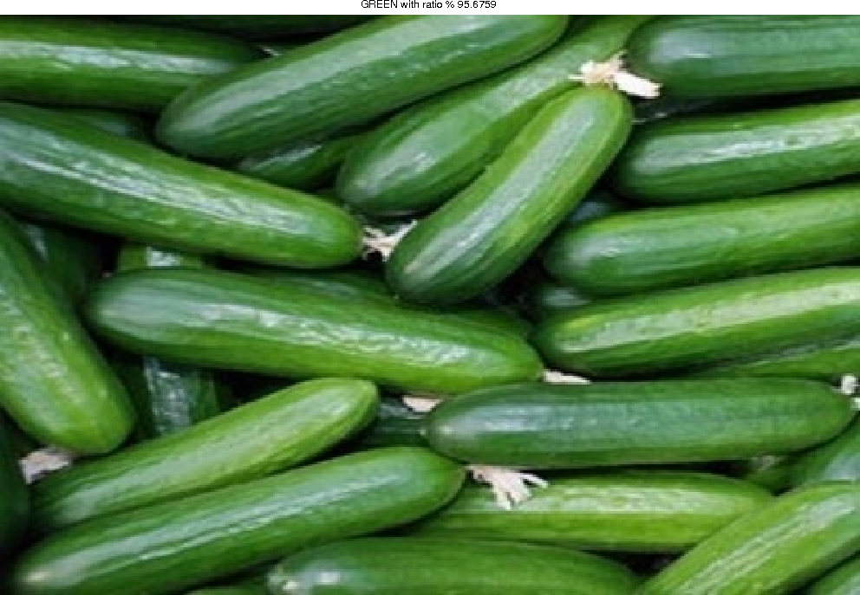

IMAGE: cucumber.jpg

% 95.7 GREEN

% 02.4 WHITE

% 00.4 YELLOW

% 00.1 BLUE

% 00.1 RED

% 00.1 ORANGE

% 00.0 VIOLET

**Orange** 92.9%

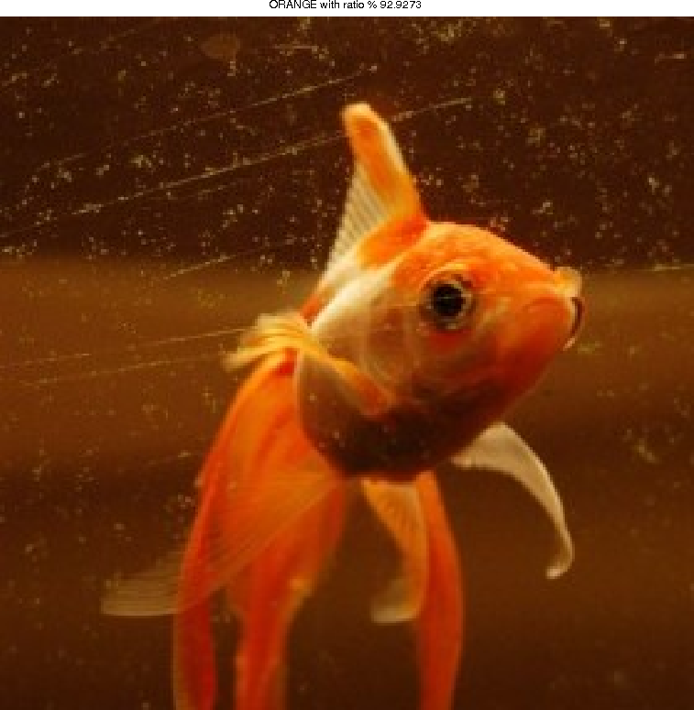

IMAGE: fish.jpg

% 92.9 ORANGE

% 05.4 RED

% 00.0 YELLOW

% 00.0 WHITE

% 00.0 GREEN

% 00.0 BLUE

% 00.0 VIOLET

**Green** 84.0%

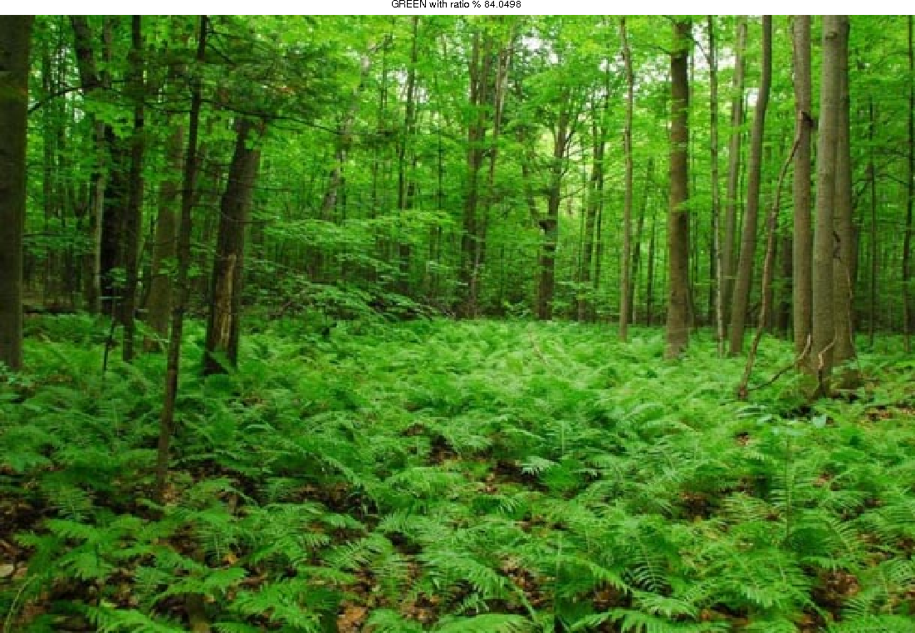

IMAGE: forest.jpg

% 84.0 GREEN

% 08.2 YELLOW

% 00.3 ORANGE

% 00.3 WHITE

% 00.0 RED

% 00.0 BLUE

% 00.0 VIOLET

**Green** 30.4%

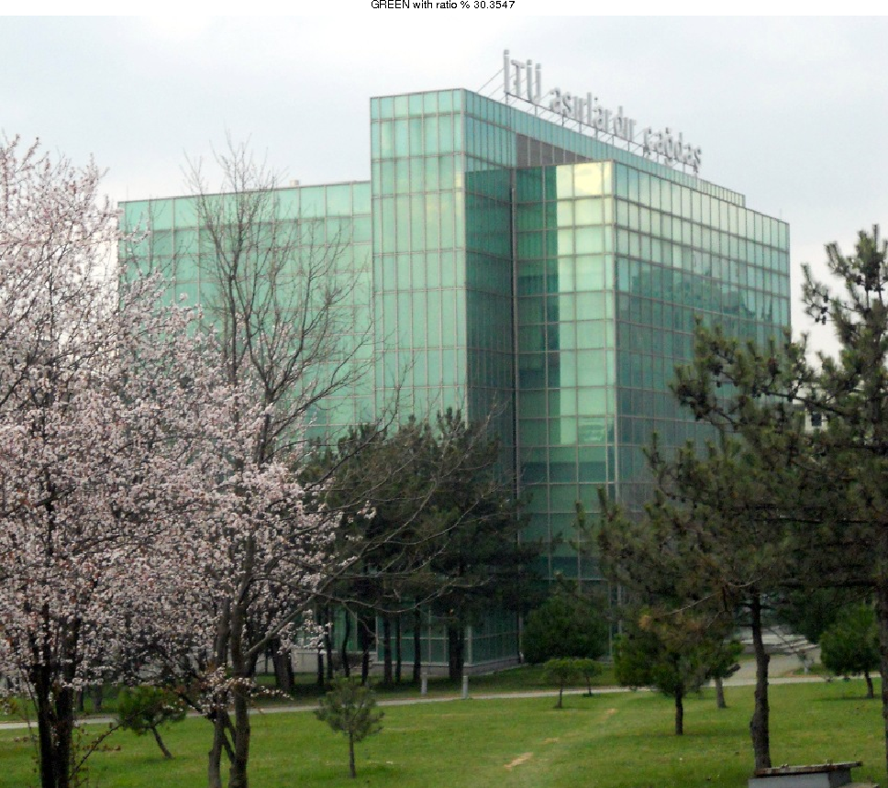

IMAGE: itu.jpg

% 30.4 GREEN

% 26.4 WHITE

% 09.6 YELLOW

% 08.2 ORANGE

% 05.7 RED

% 00.7 BLUE

% 00.1 VIOLET

**White** 28.6%

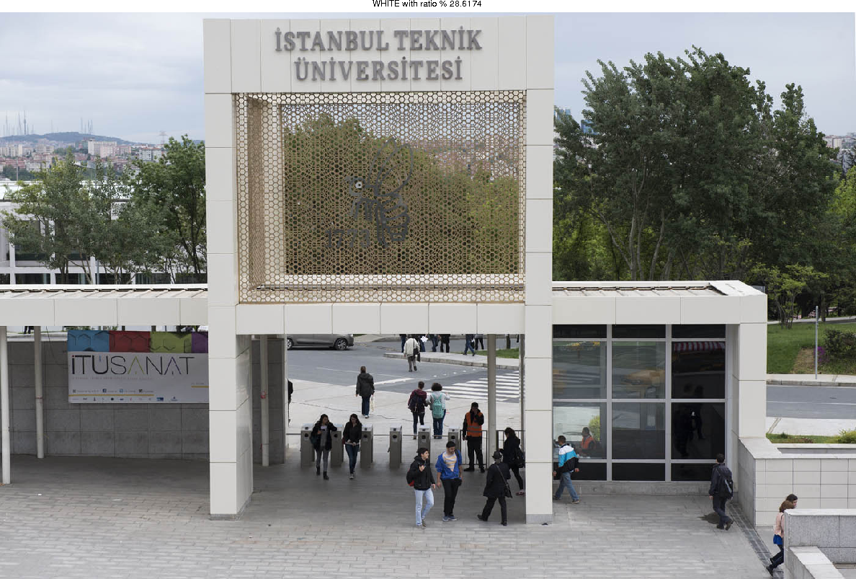

IMAGE: ituenterence.jpg

% 28.6 WHITE

% 17.4 BLUE

% 10.8 GREEN

% 10.6 ORANGE

% 08.2 YELLOW

% 07.2 RED

% 01.0 VIOLET

**White** 83.8%

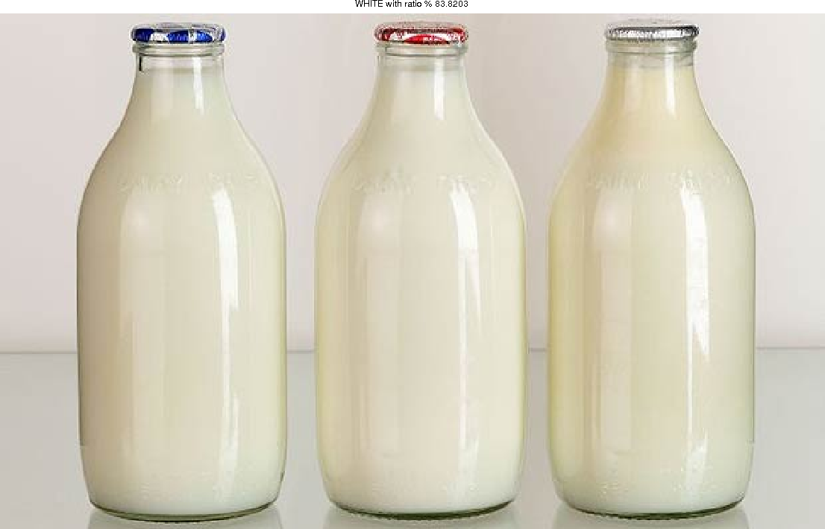

IMAGE: milk.jpg

% 83.8 WHITE

% 09.8 YELLOW

% 02.6 ORANGE

% 00.3 RED

% 00.2 BLUE

% 00.2 GREEN

% 00.0 VIOLET

**Orange** 66.3%

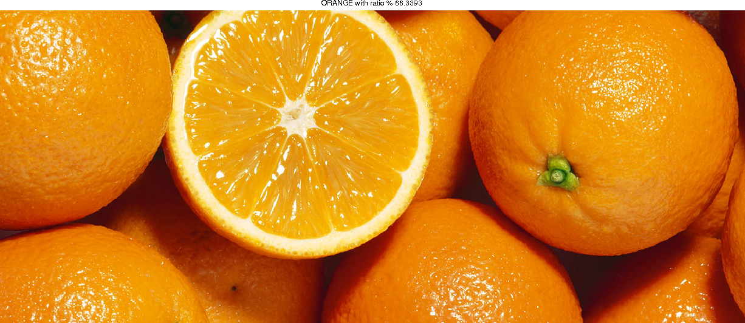

IMAGE: orange.jpg

% 66.3 ORANGE

% 12.8 RED

% 07.0 YELLOW

% 02.5 WHITE

% 00.1 GREEN

% 00.0 BLUE

% 00.0 VIOLET

**Yellow** 61.8%

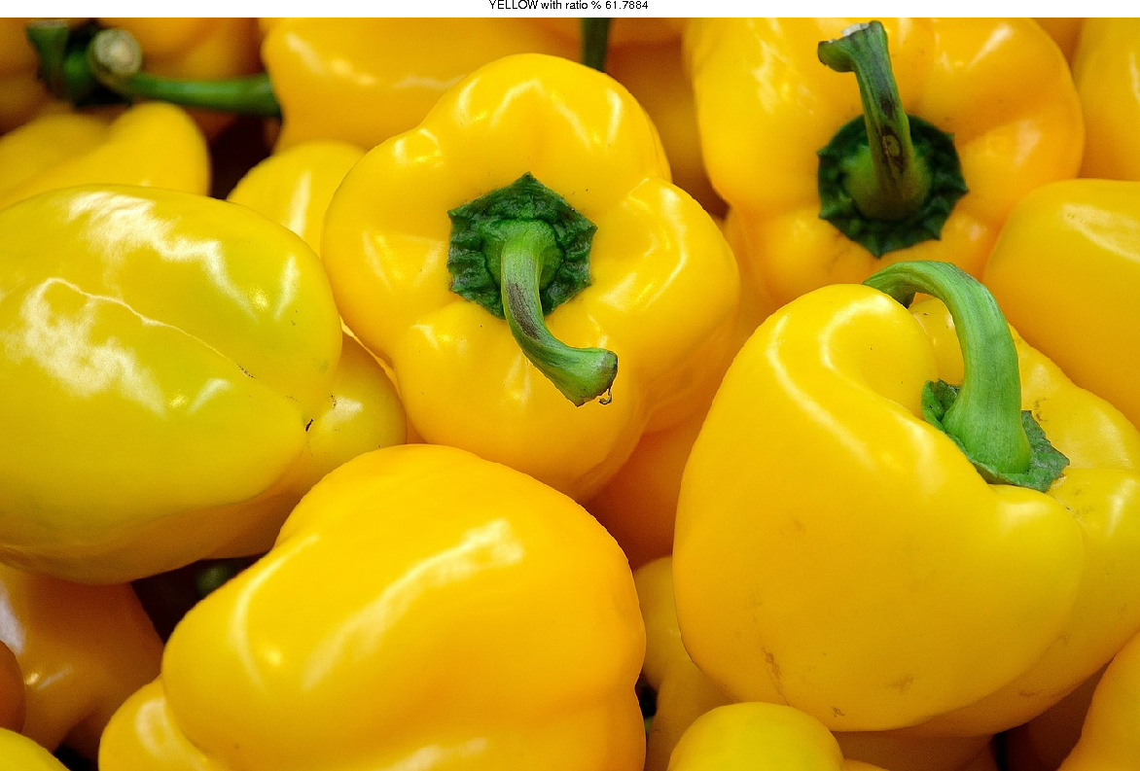

IMAGE: pepper.jpg

% 61.8 YELLOW

% 19.4 ORANGE

% 04.9 GREEN

% 01.4 RED

% 00.0 WHITE

% 00.0 BLUE

% 00.0 VIOLET

**Green** 53.2%

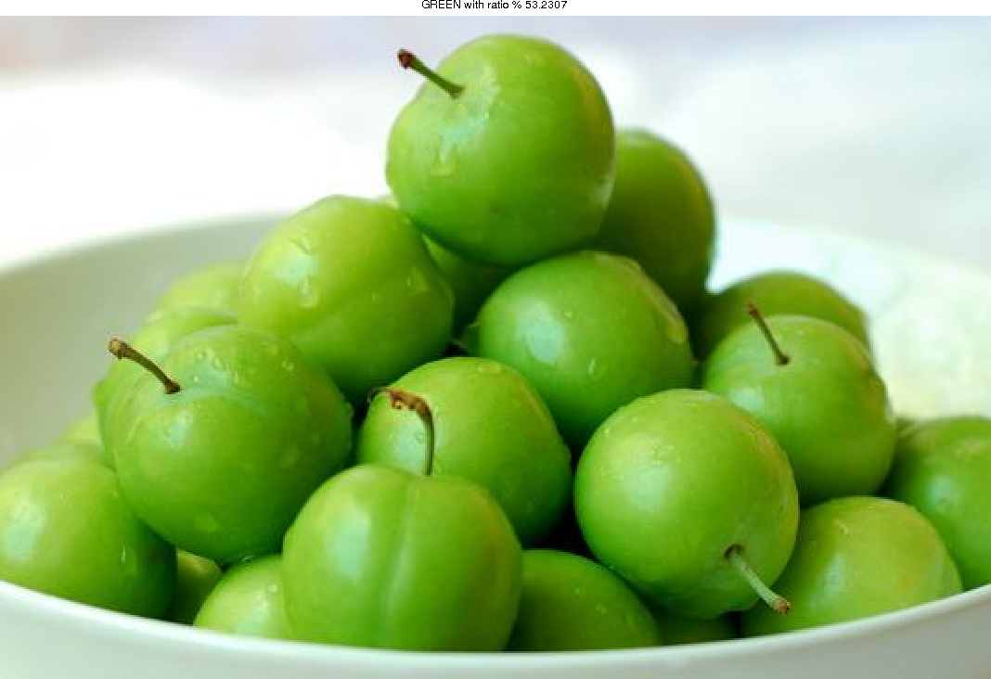

IMAGE: plums.jpg

% 53.2 GREEN

% 34.8 WHITE

% 00.8 YELLOW

% 00.0 ORANGE

% 00.0 RED

% 00.0 BLUE

% 00.0 VIOLET

**Red** 58.2%

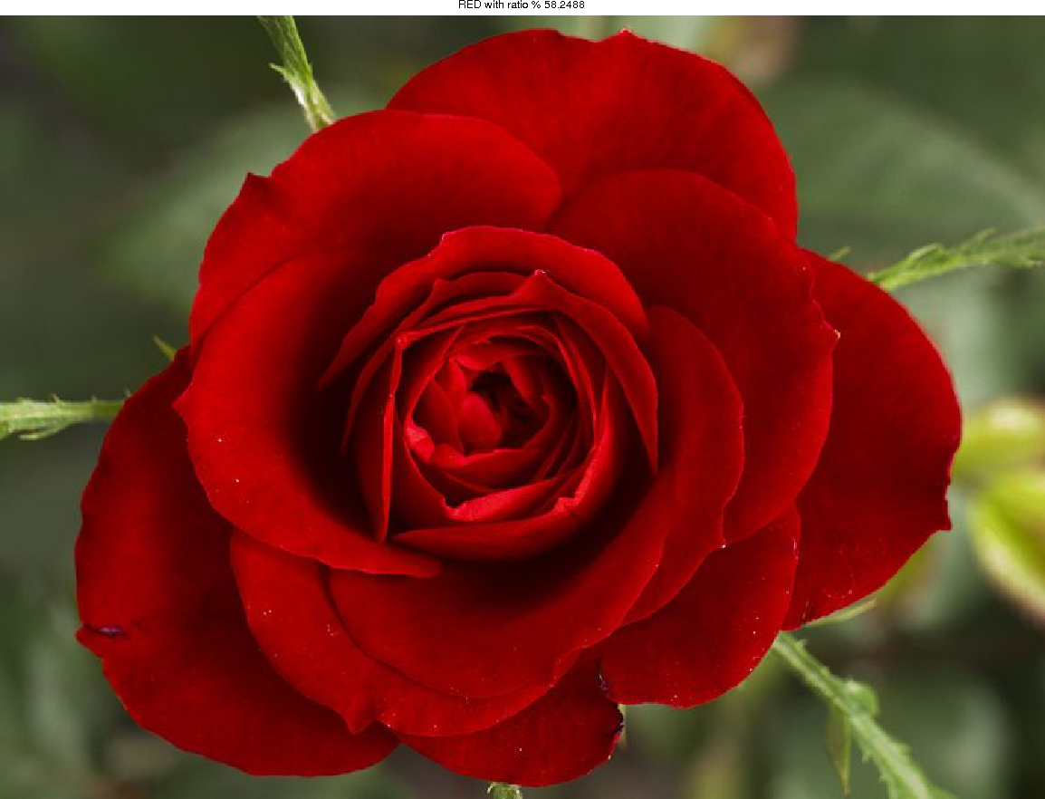

IMAGE: rose.jpg

% 58.2 RED

% 13.8 GREEN

% 12.3 YELLOW

% 01.9 ORANGE

% 00.0 WHITE

% 00.0 BLUE

% 00.0 VIOLET

**Blue** 87.1%

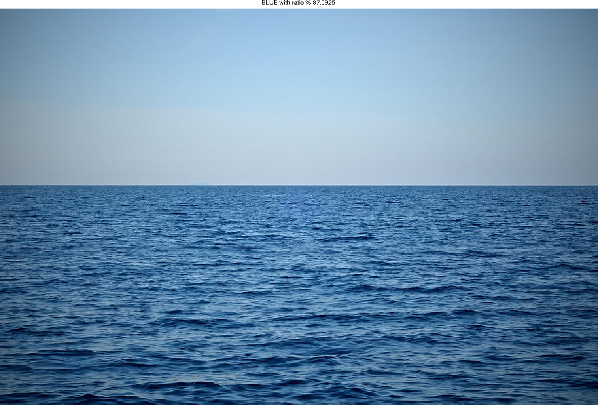

IMAGE: sea.jpg

% 87.1 BLUE

% 12.9 WHITE

% 00.0 VIOLET

% 00.0 RED

% 00.0 ORANGE

% 00.0 YELLOW

% 00.0 GREEN

**Blue** 63.9%

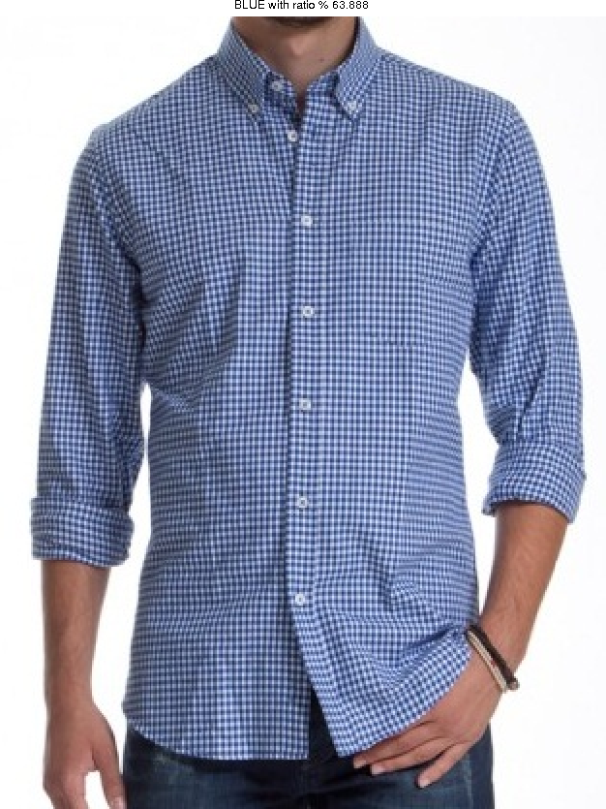

IMAGE: shirt.jpg

% 63.9 BLUE

% 27.1 WHITE

% 06.2 RED

% 01.0 ORANGE

% 00.2 VIOLET

% 00.0 YELLOW

% 00.0 GREEN

**White** 45.6%

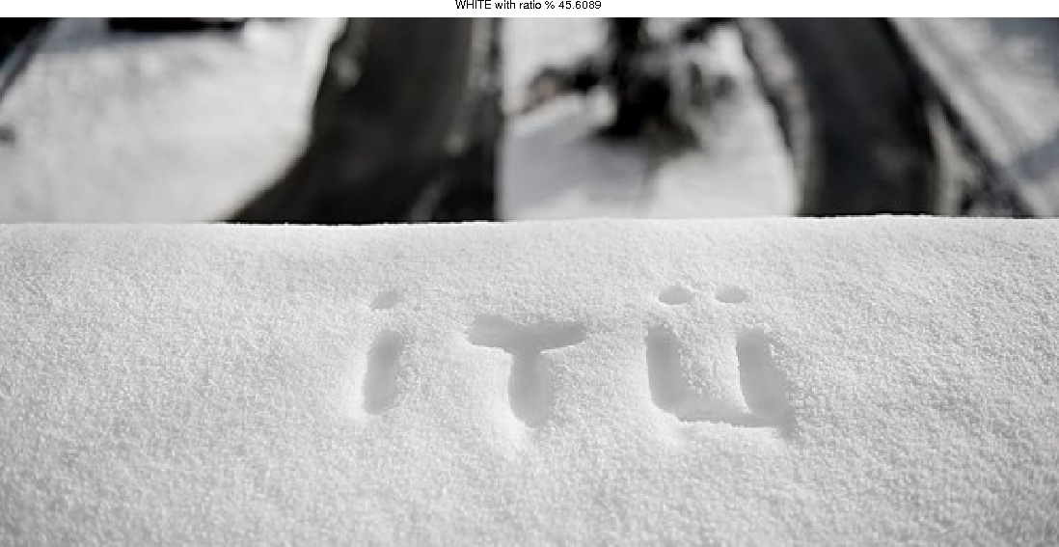

IMAGE: snow.jpg

% 45.6 WHITE

% 32.0 RED

% 10.0 BLUE

% 04.5 YELLOW

% 03.5 ORANGE

% 00.7 GREEN

% 00.1 VIOLET

**Red** 58.5%

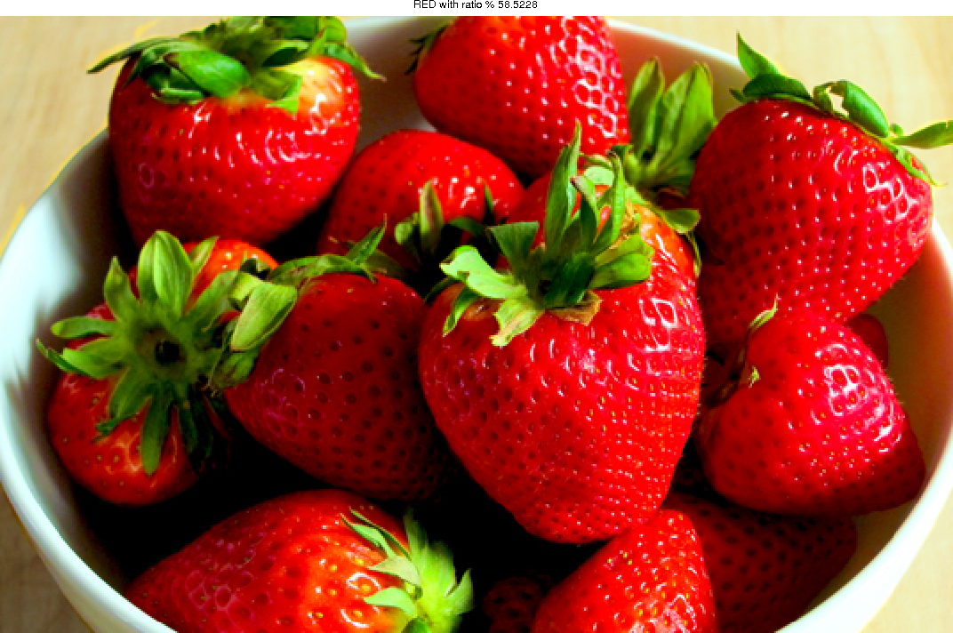

IMAGE: strawberry.jpg

% 58.5 RED

% 11.7 YELLOW

% 09.1 ORANGE

% 08.7 GREEN

% 05.5 WHITE

% 00.4 BLUE

% 00.1 VIOLET

**Red** 77.7%

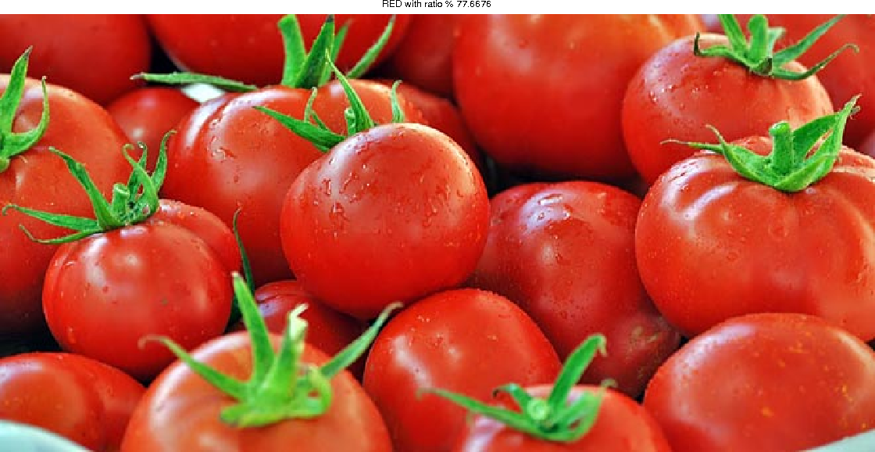

IMAGE: tomato.jpg

% 77.7 RED

% 08.8 GREEN

% 06.5 ORANGE

% 02.4 WHITE

% 01.4 YELLOW

% 00.2 BLUE

% 00.1 VIOLET

**Yellow** 26.6%

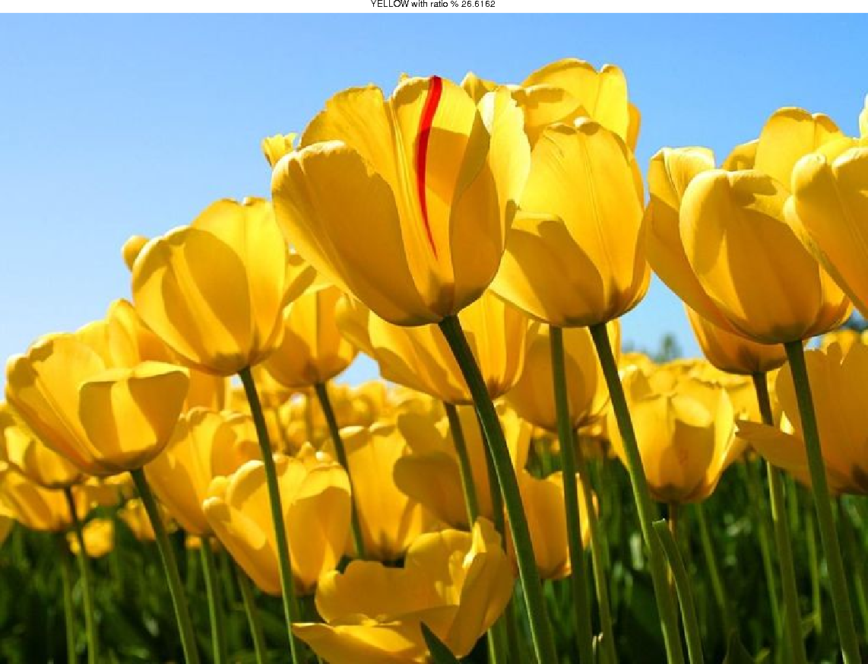

IMAGE: tulip.jpg

% 26.6 YELLOW

% 24.9 ORANGE

% 21.5 BLUE

% 07.0 GREEN

% 01.6 WHITE

% 00.2 RED

% 00.0 VIOLET